1.Matrix addition.

import java.util.\*;  
public class matrixadd {  
 public static void main(String[] args) {  
 int r, c, i, j;  
 int a[][] = new int[15][15];  
 int b[][] = new int[15][15];  
 int add[][] = new int[15][15];  
 Scanner s = new Scanner(System.*in*);  
 System.*out*.println("enter number of rows ");  
 r = s.nextInt();  
 System.*out*.println("enter number of col ");  
 c = s.nextInt();  
 System.*out*.println("enter ele of a matrix...");  
 for (i = 0; i < r; i++) {  
 for (j = 0; j < c; j++) {  
 a[i][j] = s.nextInt();  
 }  
 }  
 System.*out*.println("enter ele of b matrix...");  
 for (i = 0; i < r; i++) {  
 for (j = 0; j < c; j++) {  
 b[i][j] = s.nextInt();  
 }  
  
 }  
  
 for (i = 0; i < r; i++) {  
  
 for (j = 0; j < c; j++) {  
 add[i][j]=a[i][j]+b[i][j];  
  
 }}  
  
 System.*out*.println("result matrix...");  
  
 for (i = 0; i < r; i++) {  
  
 for (j = 0; j < c; j++) {  
  
 System.*out*.println(add[i][j]);  
 }  
  
  
 }  
  
  
  
 }}

Output.

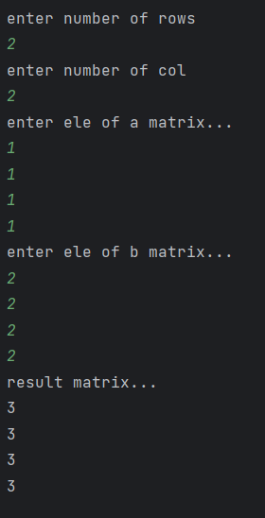

2.Matrix subtraction.

import java.util.\*;  
public class matrixsub {  
 public static void main(String[] args) {  
 int r, c, i, j;  
 int a[][] = new int[15][15];  
 int b[][] = new int[15][15];  
 int sub[][] = new int[15][15];  
 Scanner s = new Scanner(System.*in*);  
 System.*out*.println("enter number of rows ");  
 r = s.nextInt();  
 System.*out*.println("enter number of col ");  
 c = s.nextInt();  
 System.*out*.println("enter ele of a matrix...");  
 for (i = 0; i < r; i++) {  
 for (j = 0; j < c; j++) {  
 a[i][j] = s.nextInt();  
 }  
 }  
 System.*out*.println("enter ele of b matrix...");  
 for (i = 0; i < r; i++) {  
 for (j = 0; j < c; j++) {  
 b[i][j] = s.nextInt();  
 }  
  
 }  
  
 for (i = 0; i < r; i++) {  
  
 for (j = 0; j < c; j++) {  
 sub[i][j]=a[i][j]-b[i][j];  
  
 }}  
  
 System.*out*.println("result matrix...");  
  
 for (i = 0; i < r; i++) {  
  
 for (j = 0; j < c; j++) {  
  
 System.*out*.println(sub[i][j]);  
 }  
  
  
 }  
  
  
  
 }}

Output.

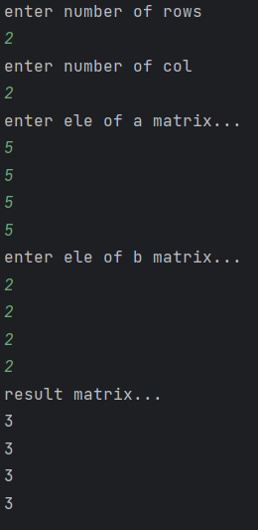

3.Matrix multiplication.

import java.util.\*;  
public class matmul {  
 public static void main(String[] args) {  
 int r,c,i,j,k;  
 int a[][]=new int[15][15];  
 int b[][]=new int[15][15];  
 int mul[][]=new int[15][15];  
 Scanner s=new Scanner(System.*in*);  
 System.*out*.println("enter number of rows ");  
 r=s.nextInt();  
 System.*out*.println("enter number of col ");  
 c=s.nextInt();  
 System.*out*.println("enter ele of a matrix...");  
 for(i=0;i<r;i++){  
 for(j=0;j<c;j++)  
 {  
 a[i][j]=s.nextInt();  
 }  
 }  
 System.*out*.println("enter ele of b matrix...");  
 for(i=0;i<r;i++){  
 for(j=0;j<c;j++)  
 {  
 b[i][j]=s.nextInt();  
 }  
  
 }  
  
 for(i=0;i<r;i++){  
  
 for(j=0;j<c;j++)  
 {  
 mul[i][j]=0;  
 for(k=0;k<c;k++){  
 mul[i][j]+=a[i][k]\*b[k][j];}  
 }  
  
 }  
 System.*out*.println("a matrix...");  
 for(i=0;i<r;i++){  
 for(j=0;j<c;j++)  
 {  
 System.*out*.println(a[i][j]);  
 }  
 }  
 System.*out*.println("b matrix...");  
 for(i=0;i<r;i++){  
 for(j=0;j<c;j++)  
 {  
 System.*out*.println(b[i][j]);  
 }  
 }  
 System.*out*.println("result matrix...");  
 for(i=0;i<r;i++){  
  
 for(j=0;j<c;j++)  
 {  
  
 System.*out*.println(mul[i][j]);  
 }  
  
  
 }  
  
 }  
  
}

output.

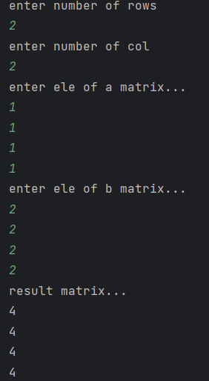

4.Average of 15 students marks in array.

import java.util.\*;  
public class array {  
 public static void main(String[] args) {  
 int a[]=new int[20];  
 int i,sum=0,avg=0;  
 Scanner s=new Scanner(System.*in*);  
 System.*out*.println("enter 15 marks");  
 for(i=0;i<15;i++){  
 a[i]=s.nextInt();  
 sum+=a[i];  
 }  
  
 System.*out*.println("sum = "+sum);  
 avg=sum/15;  
 System.*out*.println("average = "+avg);  
 }  
}

Output.

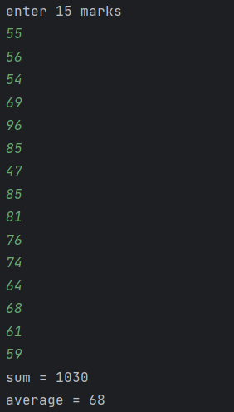

5.Area of rectangle (class).

public class rectangle {  
 void rect(int l,int b){  
 int area=l\*b;  
 System.*out*.println("area of rectangle = "+area);  
 }  
  
 public static void main(String[] args) {  
 rectangle r=new rectangle();  
 r.rect(10,5);  
 }  
}

Output.



6.Area of circle (class).

public class circle {  
 void cir(int r){  
 double area=3.14\*r\*r;  
 System.*out*.println("area of circle = "+area);  
 }  
  
 public static void main(String[] args) {  
 circle c=new circle();  
 c.cir(5);  
 }  
}

Output.



7.Area of triangle (class).

public class areaoftriangle {  
 void triangle(int b,int h){  
 double area=0.5\*b\*h ;  
 System.*out*.println("area of triangle = "+area);  
 }  
  
 public static void main(String[] args) {  
 areaoftriangle t=new areaoftriangle();  
 t.triangle(12,10);  
  
 }  
  
}

Output.



8.Simple interest(class).

import org.w3c.dom.ls.LSOutput;  
  
import java.util.\*;  
public class roi {  
 void interset(int p,int y,int r){  
 int roi=p\*y\*r/100;  
 System.*out*.println("interset = "+roi);  
 }  
 public static void main(String[] args) {  
 int p,y,r;  
 Scanner s=new Scanner(System.*in*);  
 System.*out*.println("enter principle amount ");  
 p=s.nextInt();  
 System.*out*.println("enter no of years ");  
 y=s.nextInt();  
 System.*out*.println("enter rate of interset ");  
 r=s.nextInt();  
 roi r1=new roi();  
 r1.interset(p,y,r);  
  
 }  
}

Output.

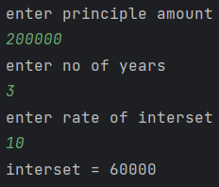

9.Sum of series(class).

import java.util.\*;  
public class sos {  
 void sumofseries(int n){  
  
 int sum=0;  
 for(int i=0;i<=n;i++){  
  
 sum+=i;  
 }  
 System.*out*.println("sum = "+sum);  
 }  
  
 public static void main(String[] args) {  
 int n;  
 Scanner s=new Scanner(System.*in*);  
 System.*out*.println("enter limit ");  
 n=s.nextInt();  
 sos o=new sos();  
 o.sumofseries(n);  
 }  
}

Output.

